**Program Code -**

SET SERVEROUTPUT ON

BEGIN

DBMS_OUTPUT.PUT_LINE('==============================');

DBMS_OUTPUT.PUT_LINE(' CURSOR MENU ');

DBMS_OUTPUT.PUT_LINE('==============================');

DBMS_OUTPUT.PUT_LINE('1. Implicit Cursor (1 row at a time)');

DBMS_OUTPUT.PUT_LINE('2. Explicit Cursor');

DBMS_OUTPUT.PUT_LINE('3. Cursor FOR Loop');

DBMS_OUTPUT.PUT_LINE('4. Parameterized Cursor');

DBMS_OUTPUT.PUT_LINE('==============================');

END;

/

-- Accept user choice

ACCEPT choice NUMBER PROMPT 'Enter your choice (1-4): '

-- PL/SQL block: reset O_RollCall, insert base rows, merge

DECLARE

v_choice NUMBER := &choice;

CURSOR c_explicit IS

SELECT RollNo, Name, Status FROM N_RollCall;

CURSOR c_param(p_roll NUMBER) IS

SELECT RollNo, Name, Status FROM N_RollCall WHERE RollNo = p_roll;

v_rec N_RollCall%ROWTYPE;

BEGIN

-- Reset O_RollCall

EXECUTE IMMEDIATE 'TRUNCATE TABLE O_RollCall';

-- Insert base 3 rows

INSERT INTO O_RollCall VALUES (1, 'Rahul', 'Present');

INSERT INTO O_RollCall VALUES (2, 'Amit', 'Absent');

INSERT INTO O_RollCall VALUES (3, 'Suresh', 'Present');

COMMIT;

-- Merge logic based on choice

IF v_choice = 1 THEN

-- Implicit cursor row-by-row: insert only 1 new row

BEGIN

DECLARE

v_r N_RollCall%ROWTYPE;

BEGIN

SELECT RollNo, Name, Status

INTO v_r.RollNo, v_r.Name, v_r.Status

FROM N_RollCall n

WHERE NOT EXISTS (SELECT 1 FROM O_RollCall o WHERE o.RollNo = n.RollNo)

AND ROWNUM = 1;

INSERT INTO O_RollCall VALUES (v_r.RollNo, v_r.Name, v_r.Status);

EXCEPTION

WHEN NO_DATA_FOUND THEN NULL;

END;

END;

ELSIF v_choice = 2 THEN

-- Explicit cursor: loop through all rows

OPEN c_explicit;

LOOP

FETCH c_explicit INTO v_rec.RollNo, v_rec.Name, v_rec.Status;

EXIT WHEN c_explicit%NOTFOUND;

BEGIN

INSERT INTO O_RollCall

SELECT v_rec.RollNo, v_rec.Name, v_rec.Status

FROM dual

WHERE NOT EXISTS (SELECT 1 FROM O_RollCall o WHERE o.RollNo = v_rec.RollNo);

EXCEPTION

WHEN DUP_VAL_ON_INDEX THEN NULL;

END;

END LOOP;

CLOSE c_explicit;

ELSIF v_choice = 3 THEN

-- Cursor FOR loop

FOR rec IN c_explicit LOOP

BEGIN

INSERT INTO O_RollCall

SELECT rec.RollNo, rec.Name, rec.Status

FROM dual

WHERE NOT EXISTS (SELECT 1 FROM O_RollCall o WHERE o.RollNo = rec.RollNo);

EXCEPTION

WHEN DUP_VAL_ON_INDEX THEN NULL;

END;

END LOOP;

ELSIF v_choice = 4 THEN

-- Parameterized cursor

FOR rec IN (SELECT RollNo FROM N_RollCall) LOOP

OPEN c_param(rec.RollNo);

FETCH c_param INTO v_rec;

IF v_rec.RollNo IS NOT NULL THEN

BEGIN

INSERT INTO O_RollCall

SELECT v_rec.RollNo, v_rec.Name, v_rec.Status

FROM dual

WHERE NOT EXISTS (SELECT 1 FROM O_RollCall o WHERE o.RollNo = v_rec.RollNo);

EXCEPTION

WHEN DUP_VAL_ON_INDEX THEN NULL;

END;

END IF;

CLOSE c_param;

END LOOP;

END IF;

END;

/

SELECT RollNo, Name, Status FROM O_RollCall ORDER BY RollNo;

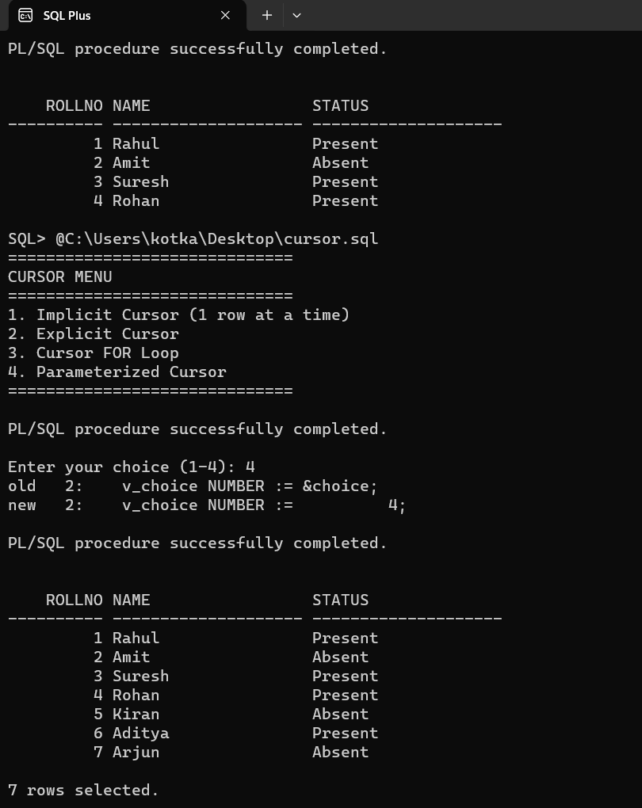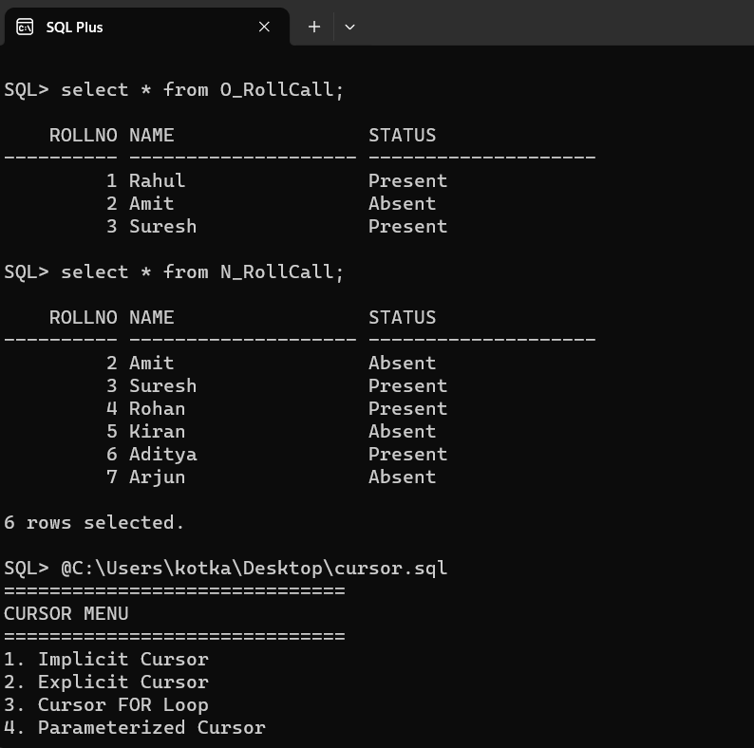**Output –**